A Community Engagement Project Report on
“Personal Finance & Expense Analyzer”
submitted by
Kedar Pophale (B24AD1003)
Spandan Wasnik (B24AD1005)
Om Dhakane (B24AD1007)
Sanchita Pathak (B24AD1024)
Under the guidance of
Dr. Dhanraj Dhotre

Department Of AI & DS
Marathwada Mitra Mandal's College of Engineering
Karvenagar, Pune-411052 , Maharashtra, India
2025 -2026 Semester-V

CERTIFICATE
This is to certify that the mini project report entitled “Personal Finance & Expense Analyzer” being submitted by Kedar Pophale, Spandan Wasnik, Om Dhakane and Sanchita Pathak is a record of bonafide work carried out by them under the supervision and guidance of Dr. Dhanraj Dhotre in partial fulfillment of the requirement for
T.Y.B-TECH (Artificial Intelligence and Data Science) in the academic year 2025-2026 Sem-V.
Date:23/10/2026
Place: Pune

_____________________  Project Guide | _____________________  Head of the Department | _____________________  Principal
Dr. Dhanraj Dhotre | Dr. Dhanraj Dhotre | Dr. Sachin Sakhare

i
ACKNOWLEDGEMENT
It gives us great pleasure in presenting the mini project report on ‘Personal Finance & Expense Analyzer’.
We would like to take this opportunity to thank our internal guide Dr. Dhanraj Dhotre for giving us all the help and guidance we needed. We are really grateful to him for his kind support and valuable technical suggestions throughout the development.
We also express our sincere gratitude to our respected Principal Dr. Sachin Sakhare and the faculty members of the Department of Artificial Intelligence and Data Science for providing the academic facilities, labs, and guidance required to carry out this project successfully.
At last but not the least, we are greatly indebted to others who directly or indirectly helped us during this course.
Kedar Pophale
Spandan Wasnik
Om Dhakane
Sanchita Pathak
(T.Y.B.Tech. AI&DS)
ii
TABLE OF CONTENTS
Sr. No. | Title of Chapter | Page No.
1. | Introduction | 1
1.1 | Motivation | 2
1.2 | Objective | 3
1.3 | Problem Statement and Scope of the Project | 4
1.4 | Curricular Subject Competencies Mapping | 5
2. | System Architecture | 6
2.1 | System Design | 6
2.2 | Database Design | 8
2.3 | Hardware / Software Used | 11
2.4 | Methodology / Algorithm Used | 12
3. | Implementation And Result | 15
3.1 | Implementation Details | 15
3.2 | Results and Outcomes | 16
4. | Conclusion | 23
5. | References | 25
iii
CHAPTER 1
INTRODUCTION
This project focuses on developing an intelligent, proactive personal finance management system that combines automated statement ingestion (from UPI apps like PhonePe, Paytm, and Google Pay, as well as bank exports) with machine learning-based expenditure forecasting and anomaly detection. Rather than merely acting as a passive historical ledger, the system implements a continuous 6-stage analytical pipeline designed to forecast month-end category spending, detect overspending halfway through the month, calculate its exact negative impact on planned savings, and provide actionable safe daily spending quotas. By prioritizing forward-looking financial preservation over backward-looking record keeping, the application empowers users to take control of their finances before their monthly budget is exhausted.
Over the past decade, consumer spending dynamics in India have been revolutionized by the widespread adoption of digital transaction platforms. The Unified Payments Interface (UPI), spearheaded by the National Payments Corporation of India (NPCI), has facilitated instantaneous, frictionless, and mobile-centric monetary transfers across millions of merchants, online portals, and peer-to-peer exchanges. While this technological leap has delivered unmatched convenience and economic efficiency, it has fundamentally transformed consumer psychology. The physical sensation of parting with paper currency, an inherent psychological deterrent against excessive discretionary spending known in behavioral economics as the 'pain of paying' has been largely decoupled from modern commercial transactions. Consequently, individuals frequently execute numerous low-ticket digital transactions daily without maintaining an active mental accounting of their cumulative expenditure velocity.
Furthermore, contemporary consumers maintain accounts across multiple digital payment platforms and financial institutions. A typical user may utilize PhonePe for local grocery and tea purchases, Paytm for utility recharges, Google Pay for peer transfers, alongside credit cards and net banking for major purchases. Because transaction records remain siloed within individual platform applications, gaining an integrated, real-time overview of monthly cash flow is exceptionally difficult. Individuals typically discover budgetary depletion only toward the conclusion of the billing cycle, when monthly bank statements are reviewed or when account balances are exhausted. At that juncture, corrective behavioral adjustments are impossible, leading to systemic under-saving, financial stress, and chronic failure to achieve medium- and long-term financial milestones.
To resolve this structural challenge, this project develops a unified software platform that consolidates disparate statement exports into a normalized relational database, applies predictive linear regression modeling on cumulative daily trajectories, flags uncharacteristic spending outliers using unsupervised machine learning, and dynamically allocates safe daily spending targets. By prioritizing local execution, the system guarantees complete confidentiality of user financial records while delivering continuous, actionable decision support.
1
1.1 MOTIVATION
With the rapid adoption of digital payment infrastructure like UPI, debit cards, and net banking, day-to-day transactions have become frictionless. However, this ease of payment leads to a widespread behavioral challenge: silent overspending. Small, repeated micro-transactions across fast-moving categories, such as dining out, quick grocery delivery, ride-hailing services, and online shopping, quietly accumulate without user awareness. Because individual expenditures (e.g., ₹80 for snacks, ₹150 for auto-rickshaw rides, ₹250 for food delivery) appear financially insignificant in isolation, they fail to trigger conscious resistance. Over the course of fifteen to twenty days, these repeated disbursements coalesce into substantial sums, often consuming between 40% and 60% of an individual's discretionary income.
The motivation behind this project arises from the critical recognition that existing commercial Personal Finance Management solutions fail to resolve this dilemma due to two fundamental architectural and conceptual deficiencies:
- 1. Passive Historical Reporting vs. Proactive Predictive Pacing: The vast majority of existing expense tracking tools (e.g., Walnut, Spendee, Money Lover, and standard banking portals, Paisa Tracker,) function as backward-looking ledgers. They record transactions and present attractive retrospective charts illustrating where capital was disbursed after the monthly billing period has concluded. Informing a consumer on Day 30 that they exceeded their restaurant budget by ₹7,500 provides zero prospective utility for wealth preservation; the funds are already spent and planned savings are irrevocably lost. To foster genuine financial discipline, users require prospective forecasting delivered mid-month (e.g., on Day 12 or 15) that projects where their spending trajectory will land by month-end, quantifies the exact risk to their savings, and calculates an actionable, safe daily expenditure target for the remainder of the month.
- 2. Privacy Invasions and Centralized Cloud Vulnerabilities: Commercial tracking applications commonly require invasive smartphone permissions specifically continuous READ_SMS access to scrape transaction notifications or mandate that users link their bank accounts through third-party cloud aggregators by surrendering net banking credentials. In an era characterized by frequent corporate data breaches, telemetry harvesting, and monetization of consumer spending habits, users are increasingly uncomfortable exposing sensitive financial records to commercial cloud servers. Moreover, modern mobile operating systems (iOS and Android) have enacted strict sandboxing policies that restrict SMS scraping, causing automated SMS parsers to suffer data omission rates exceeding 30%. There is a profound need for a private, locally deployable solution that analyzes official statement exports securely without cloud leakage.
2
Motivated by these challenges, the Personal Finance & Expense Analyzer was conceptualized as a local-first, privacy-preserving, and forward-looking financial management platform. By uniting automated statement ingestion, deterministic categorization, Ordinary Least Squares (OLS) regression trajectory forecasting, and unsupervised anomaly detection, the system shifts personal financial management from passive bookkeeping to active capital protection.
1.2 OBJECTIVE
This project performs automated transaction ingestion, preprocessing, predictive regression modeling, and savings protection through a continuous 6-stage pipeline. The system is designed to fulfill ten comprehensive engineering objectives:
- Automated Multi-Source Ingestion: Build a resilient statement parsing engine capable of ingesting raw CSV and Excel exports from PhonePe, Paytm, Google Pay, and generic commercial banks, featuring dynamic header discovery (evaluating up to 50 lines) and automated legal disclaimer footer pruning.
- Multi-Format Data Normalization: Sanitize unstructured currency tokens (₹, Rs., INR, commas, whitespace) and parse diverse international and domestic date format masks into standardized SQL DATE representations.
- Category Classification: Implement a high-throughput inverted index keyword lexicon that tags unstructured payee strings across eight functional spending categories (Food, Transport, Shopping, Entertainment, Bills, Education, Health, Travel, and Other).
- Three-Tier Spending Nature Taxonomy: Classify expenses into Fixed contractual commitments (Rent, EMI, Insurance), Recurring-Variable necessities (Utilities, Groceries), and Discretionary Variable expenditures (Dining, Shopping) to isolate controllable lifestyle spending.
- Relational Schema: Architect an ACID-compliant MySQL relational database to maintain transactional referential integrity, support cascading deletions, and optimize temporal grouping queries.
- Cumulative Trajectory OLS Spend Forecasting: Fit Ordinary Least Squares Linear Regression onto cumulative daily expenditure trajectories to project month-end (Day 30) category spending as early as mid-month, constrained by physical spend floor boundaries.
- Unsupervised Outlier & Anomaly Detection: Deploy an Isolation Forest ensemble to identify and flag abnormal, spike spending transactions in real time.
3
- Savings Protection & Dynamic Budget Pacing: Translate anticipated category overruns into monetary 'Savings at Risk' and dynamically allocate remaining budget allowances into actionable Safe Daily Spending Targets.
- Financial Goal Milestone Monitoring: Enable users to configure milestone savings goals with target completion dates, capital progress indicators, and monthly contribution tracking.
- Interactive Responsive Web Dashboard: Deliver a responsive, user-friendly web interface utilizing Flask, Jinja2, modern CSS, and Chart.js to render interactive KPI summary cards, expenditure distribution doughnuts, and time-series line charts.
1.3 PROBLEM STATEMENT AND SCOPE OF THE PROJECT
Problem Statement: In modern digital payment ecosystems, individuals lack a unified, privacy-preserving mechanism to consolidate fragmented transaction data across disparate UPI applications and bank accounts. Consequently, unmonitored micro-transactions cause silent budget overruns, leaving users unaware of financial distress until monthly savings are irreversibly depleted. Existing tools either compromise consumer privacy through cloud SMS scraping or provide passive, post-facto ledgers that fail to prevent overspending.
Scope of the Project: The system is engineered to operate locally within a lightweight Python-Flask and MySQL environment. The scope includes file ingestion for standard commercial statement formats (CSV, XLSX, XLS), token cleaning, automated categorization, statistical time-series regression forecasting, unsupervised anomaly isolation, and dynamic budget pacing. The system is calibrated for Indian digital payment modalities (UPI, Net Banking, Debit Cards, Cash) and targets single-user household personal finance.
Delimitations: The project focuses on user-driven statement export imports rather than direct programmatic web scraping or bank credential interception, strictly upholding user privacy. The primary currency denomination is Indian Rupees (INR), and the application is engineered as a local-first web service.
1.4 CURRICULAR SUBJECT COMPETENCIES MAPPING
This project unifies foundational concepts from the Second-Year B.Tech Artificial Intelligence & Data Science curriculum. Table 1.1 documents how core academic subjects directly map to software modules and analytical pipelines within the system.
4
Table 1.1: Curricular Mapping of Core Subject Competencies
Curricular Subject | Core Academic Concept | System Implementation Mapping | Module & Artifact
Database Management Systems (DBMS) | Relational Schema, ,ACID Transactions, Foreign Keys, SQL Aggregations | Normalized relational schema in MySQL 8.0; cascading deletions; grouping queries for cumulative spend paths; cash vs online mode partitioning. | database/schema.sql, database.py, utils/analysis.py
Data Structures & Algorithms (DSA) | Hash Maps,Traversal, Binary Search, Big-O Complexity | Fast keyword matching lexicon using dictionary hash tables; sliding-window cumulative daily sums; time-series array sorting for linear regression fitting. | utils/categorization.py, utils/prediction.py
Applied Statistics | Measures of Central Tendency, Variance, Standard Deviation, Z-Score Distribution, Linear Regression | Ordinary Least Squares linear regression for Day-30 cumulative spend projections; parametric Z-Score outlier isolation with dynamic standard deviation thresholding. | utils/prediction.py, utils/anomaly_detection.py
Problem Solving & OOP (PS-OOP) | Encapsulation, Class Abstraction, | SavingsImpactAnalyzer class encapsulating complex financial calculations; | utils/savings_impact.py, utils/expense_classifier.py

5
CHAPTER 2
SYSTEM ARCHITECTURE
The architecture of the Personal Finance & Expense Analyzer is organized into four tightly decoupled tiers that execute a continuous 6-stage analytical pipeline. This architectural structure guarantees clean separation of concerns, high throughput, robust fault tolerance, and comprehensive data privacy.
2.1 SYSTEM DESIGN
The system architecture consists of four tightly integrated tiers organized into a continuous 6-stage analytical pipeline. The interaction between these tiers ensures that raw statement exports are ingested, sanitized, classified, modeled, and presented without requiring external cloud synchronization.
- Tier 1: Presentation & Visualization Layer: Constructed using responsive HTML5, modern CSS, Jinja2 template inheritance, and Chart.js. This layer renders interactive dashboard summary cards, category expenditure doughnuts, cumulative trend lines, and tabular ledger views directly within the user's web browser.
- Tier 2: Application Controller Layer: Powered by Python Flask 3.0+. It manages HTTP request routing, session authentication, form sanitization, upload streaming, and coordinates business logic between client views and analytical engines.
- Tier 3: Machine Learning & Analytics Engine: A modular computational suite leveraging Pandas, NumPy, and Scikit-learn. It executes the core scientific routines: dynamic file parsing, semantic token categorization, cumulative OLS regression forecasting, Isolation Forest outlier isolation, and safe daily target pacing.
- Tier 4: Relational Data Persistence Layer: An ACID-compliant relational database powered by MySQL 8.0 Community Server. It enforces constraints, foreign key referential integrity, and composite index acceleration.
6
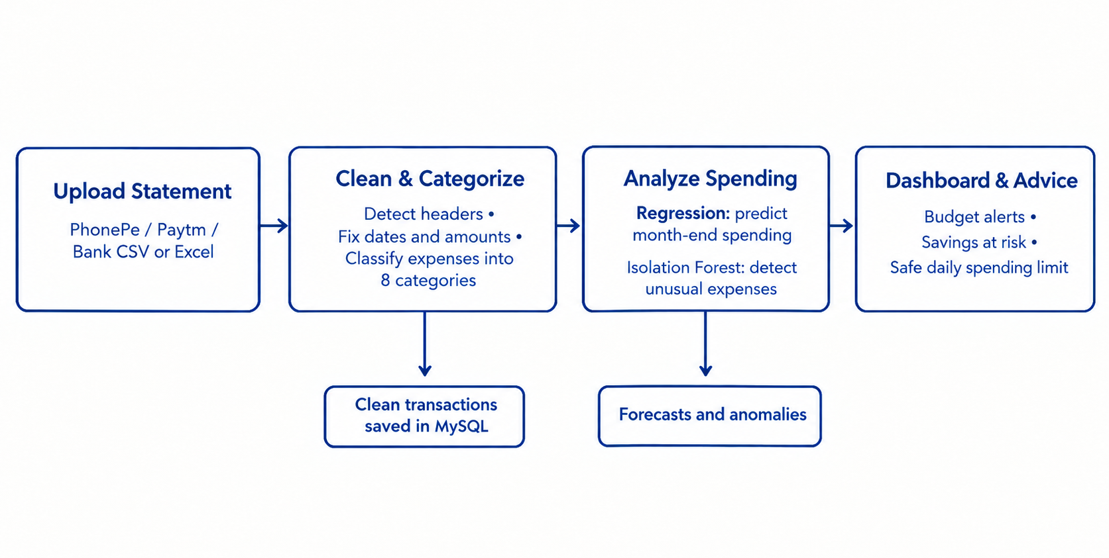
Fig 2.1: Four-Tier System Architecture and Continuous 6-Stage Analytical Pipeline
Architecture Description & Pipeline Subsystems
The system decomposes its analytical responsibilities into four dedicated functional modules:
- 1. Statement Ingestion & Header Detection Module: Ingests raw statement files (PhonePe, Paytm, Google Pay, generic bank CSV/Excel). It automatically scans the first 50 lines to discover the true table header row, bypassing account metadata, and strips trailing legal disclaimers using on_bad_lines='skip' with multi-encoding fallbacks.
- 2. Classification & Preprocessing Pipeline: Cleans currency tokens (₹, Rs., commas) and standardizes diverse dates into canonical SQL DATE format. It maps platform-specific headers to unified relational schema attributes and classifies expenses into Fixed, Recurring-Variable, and Variable spending natures.
- 3. Machine Learning & Analytical Engine: Executes SQL temporal aggregations to build cumulative daily spending trajectories. It fits Ordinary Least Squares Linear Regression to project month-end Day 30 spend and deploys an Isolation Forest ensemble (with Z-score fallback) to isolate uncharacteristic spending outliers.
- 4. Savings Impact & Dynamic Pacing Advisory: Quantifies projected budget overruns: Overrun = Predicted Spend - Budget. It calculates Savings at Risk = Planned Monthly Savings - Total Projected Overruns, and generates safe daily spending limits: Safe Target = Remaining Budget / Days Left.
7
2.2 DATABASE DESIGN
The project uses a normalized MySQL relational database (personal_finance) structured in Third Normal Form (3NF) with foreign keys and decimal precision. Storage is managed in MySQL with independent query aggregation for digital (UPI, Debit Card, Net Banking) and physical cash transactions. The relational schema comprises five core tables, documented in Table 2.1.
Table 2.1: Relational Database Schema Structure and Data Dictionary
8
Table Name | Primary Attributes | Constraints & Foreign Keys | Description & Operational Role
users | id, name, email, password, created_at | PRIMARY KEY (id), UNIQUE (email) | Stores user authentication credentials with Bcrypt salted hashing.
transactions | id, user_id, date, description, amount, type, category, expense_type, payment_mode, source, is_unusual | PRIMARY KEY (id), FOREIGN KEY (user_id) REFERENCES users(id) ON DELETE CASCADE | Master normalized ledger recording all income and expense items with DECIMAL(12,2) precision.
budgets | id, user_id, month, year, amount | PRIMARY KEY (id), UNIQUE KEY (user_id, month, year), FOREIGN KEY (user_id) | Defines monthly overall expenditure ceilings per user.
category_budgets | id, user_id, category, month, year, budget_amount | PRIMARY KEY (id), UNIQUE KEY (user_id, category, month, year), FOREIGN KEY (user_id) | Defines granular per-category monthly spending limits.
financial_goals | id, user_id, goal_name, target_amount, current_amount, monthly_contribution, target_date | PRIMARY KEY (id), FOREIGN KEY (user_id) REFERENCES users(id) ON DELETE CASCADE | Tracks multi-month milestone savings goals and allocation pacing.
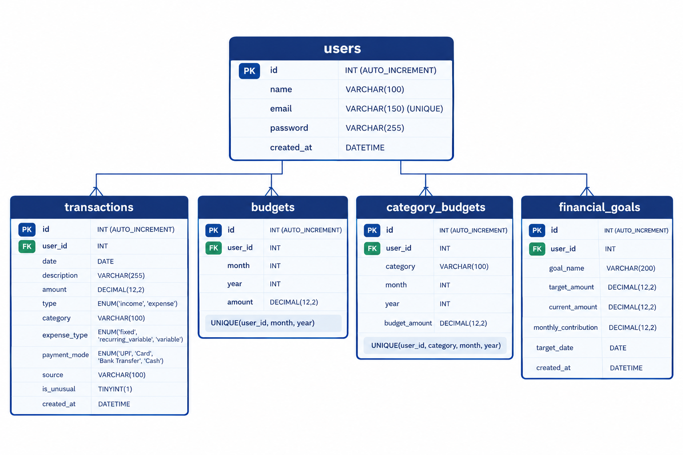
Fig 2.2: Entity-Relationship Diagram (ERD) Illustrating Table Relationships and Cardinality
Detailed Table Schema Specifications
The exact data types, constraints, and descriptions for all schema attributes are defined below:
Table 2.2: Transactions Master Table Detailed Attribute Specification
9
Attribute | Data Type | Constraints | Operational Role
id | INT | PRIMARY KEY, AUTO_INCREMENT | Unique surrogate identifier for each transaction.
user_id | INT | NOT NULL, FOREIGN KEY | References users(id) with ON DELETE CASCADE.
date | DATE | NOT NULL | Normalized transaction date in YYYY-MM-DD format.
description | VARCHAR(255) | NULLABLE | Merchant, payee, or statement narrative string.
amount | DECIMAL(12,2) | NOT NULL | Monetary transaction value stored with strict 2-decimal precision.
type | ENUM('income','expense') | NOT NULL | Monetary cash flow direction indicator.
category | VARCHAR(100) | DEFAULT 'Other' | Functional spending domain (Food, Transport, Bills, etc.).
expense_type | ENUM('fixed','recurring_variable','variable') | DEFAULT 'variable' | Behavioral financial classification of the expense.
payment_mode | ENUM('UPI','Card','Bank Transfer','Cash','Other') | DEFAULT 'Other' | Instrument utilized for transaction settlement.
source | VARCHAR(100) | DEFAULT 'Manual' | Statement origin indicator (PhonePe, Paytm, Bank, Manual).
is_unusual | TINYINT(1) | DEFAULT 0 | Flag set to 1 if flagged as statistical outlier or anomaly.

Table 2.3: Budgetary and Goal Relational Entity Specifications
Table | Attribute | Data Type | Constraint & Purpose
budgets | user_id, month, year, amount | INT, INT, INT, DECIMAL(12,2) | UNIQUE(user_id, month, year); Overall monthly ceiling.
category_budgets | user_id, category, month, year, budget_amount | INT, VARCHAR(100), INT, INT, DECIMAL(12,2) | UNIQUE(user_id, category, month, year); Category spending limit.
financial_goals | user_id, goal_name, target_amount, current_amount, monthly_contribution, target_date | INT, VARCHAR(200), DECIMAL(12,2), DECIMAL(12,2), DECIMAL(12,2), DATE | FOREIGN KEY(user_id); Tracks user milestone savings targets.
Relational Normalization and Indexing Strategy
The schema strictly adheres to Third Normal Form (3NF) principles: all attributes are atomic (1NF); all non-prime attributes fully depend on the primary key (2NF); and zero transitive functional dependencies exist (3NF). Furthermore, to guarantee sub-second dashboard rendering and support instantaneous time-series aggregations, composite indexes are deployed in MySQL: (user_id, date, type) for monthly cash flow balance queries, and (user_id, category, date) for category spend trajectory building.

10
2.3 HARDWARE / SOFTWARE USED
The system was engineered to run locally on standard consumer computing hardware without requiring expensive external cloud servers, paid APIs, or GPU accelerators.
Software Tools & Technology Stack:
- Programming Language: Python 3.10+ (Selected for scientific computing libraries, clean syntax, and rapid time-series manipulation).
- Framework & Server: Flask 3.0+ Web Framework
- Database Engine: MySQL 8.0 Community Server (ACID-compliant storage, mature foreign key cascading, robust DECIMAL precision, and fast indexing).
- Data Analytics & Machine Learning: Pandas 2.1+ (Dataframe parsing and normalization), NumPy 1.26+ (Array operations), Scikit-learn 1.3+ (LinearRegression and IsolationForest implementations).
- Frontend Presentation Layer: HTML, modern CSS, JavaScript, Chart.js (Responsive interactive charts), and Jinja2 Server Templates.
- Security & Cryptography: Bcrypt 4.0+.
Hardware Requirements:
- Processor: Standard computer with Intel Core i3 (4th Gen+) or AMD Ryzen 3 equivalent.
- Memory (RAM): 4 GB RAM minimum (8 GB recommended for smooth multi-tab browser rendering).
- Storage: 500 MB free storage for local code repository, temporary upload buffering, and MySQL database files.
- Display Resolution: 1280 x 720 minimum (1920 x 1080 recommended for multi-chart dashboard views).
2.4 METHODOLOGY / ALGORITHM USED
The core analytical pipeline executes eight sequential algorithmic steps to process financial data from ingestion to dynamic advisory generation:
Step 1 – Statement Upload & Ingestion
The user selects and uploads monthly statement exports generated from PhonePe, Paytm, Google Pay, or commercial banks (CSV or Excel format). The Flask upload controller buffers the file securely in memory and initiates the preprocessing pipeline.
Step 2 – Intelligent Header & Footer Handling
Commercial banking exports frequently prepend arbitrary metadata rows (account holder name, IFSC code) and append legal disclaimers. The system scans the first 50 lines to detect the true table header row by matching against candidate tokens ('date', 'details', 'amount', 'type'). The file is parsed with skiprows=header_idx and on_bad_lines='skip' with multi-encoding fallback (UTF-8, CP1252, Latin-1) to automatically strip footers.
11
Algorithm 1: Dynamic CSV/Excel Header Discovery Scanner
───────────────────────────────────────────────────────
1: for each encoding in ['utf-8', 'cp1252', 'latin1'] do:
2: lines = read_first_50_lines(F, encoding)
3: for i, line in enumerate(lines) do:
4: tokens = set(tokenize_lowercase(line))
5: if 'date' in tokens and size(tokens ∩ K) >= 2 then:
6: return read_csv(F, skiprows=i, encoding=encoding, on_bad_lines='skip')
7: return read_csv(F) // Fallback to default load

Step 3 – Preprocessing & Normalization
Raw monetary strings are cleansed of localized currency symbols (₹, Rs., INR), commas, and whitespace using regular expressions. Amounts in parentheses indicating debits are converted to positive floats with type='expense'. Dates across diverse format masks (YYYY-MM-DD, DD/MM/YYYY, DD-MM-YYYY) are parsed into standardized ISO-8601 SQL DATE representations.
Step 4 – Multi-Criteria Classification & Nature Tagging
Transaction narratives are evaluated against an inverted index keyword lexicon across eight standard spending domains: Food & Dining, Transport, Shopping, Bills & Utilities, Entertainment, Education, Health, and Travel. Concurrently, the nature classifier tags expenses into Fixed (Rent, EMI, Insurance), Recurring-Variable (Utilities, Prescriptions), and Discretionary Variable (Dining, Shopping) based on contractual keywords and domain contexts.
Table 2.4: Multi-Domain Semantic Lexicon and Nature Taxonomy
12
Category Domain | Representative Keywords | Spend Nature | Budgetary Elasticity
Food & Dining | swiggy, zomato, dominos, mcdonalds, kfc, burger king, mess, canteen, restaurant, café etc | Discretionary Variable | High (Primary target for daily pacing)
Transport & Commute | uber, ola, rapido, metro, irctc, petrol, fuel, diesel, shell, hpcl, parking etc | Discretionary Variable | Moderate (Commuting necessities)
Shopping & Retail | amazon, flipkart, myntra, ajio, meesho, zara, h&m, decathlon, croma, nykaa etc | Discretionary Variable | High (Impulse purchases)
Bills & Utilities | electricity, msedcl, airtel, jio, vodafone, gas, indane, water bill, recharge etc | Recurring-Variable | Low (Essential recurring utility)
Entertainment | netflix, spotify, prime video, hotstar, bookmyshow, pvr, inox, youtube, steam etc | Discretionary Variable | High (Leisure subscriptions)
Health & Medical | pharmacy, apollo, medplus, pharmeasy, hospital, clinic, doctor, lab, diagnostics etc | Recurring-Variable | Low (Inelastic medical necessity)
Education | fees, college, university, coursera, udemy, books, stationary, coaching, tution etc | Recurring-Variable | Low (Academic commitments)
Travel & Tourism | makemytrip, goibibo, yatra, cleartrip, hotel, resort, air india, indigo, irctc etc | Discretionary Variable | High (Discretionary vacations)
Step 5 – Temporal Aggregation & Cumulative Trajectory
The system executes SQL temporal grouping queries to calculate daily expenditure sums for each category: e_t =sum(amount) on day t. It then constructs monotonically increasing cumulative daily spending trajectories: day of month X in [1, current_day] versus cumulative spend Y_t:
Step 6 – OLS Linear Regression Spend Forecasting
Rather than regressing noisy daily expenditures, Ordinary Least Squares Linear Regression is fitted on the cumulative trajectory. The linear model relates day-of-month X to cumulative spend Y. The closed-form analytical normal equations are:
To project month-end expenditure for a standard 30-day billing cycle, the fitted function is evaluated at X = 30. Crucially, because cumulative expenditure can never decrease, the raw forecast is constrained by the physical spend floor:
13
Algorithm 2: OLS Cumulative Spending Trajectory Forecaster
───────────────────────────────────────────────────────
Input: User U, Category C, Month M, Year Y
Output: Projected month-end spend, daily slope velocity
1: daily_sums = query_db_daily_expenses(U, C, M, Y)
2: if current_day < 5: return average_extrapolation(daily_sums)
3: X, Y = [], []
4: cumulative = 0.0
5: for d from 1 to current_day:
6: cumulative += daily_sums.get(d, 0.0)
7: X.append([d]); Y.append(cumulative)
8: model = LinearRegression().fit(X, Y)
9: raw_pred = model.predict([[30]])[0]
10: final_pred = max(cumulative, raw_pred) // Spend floor
11: return {'predicted': round(final_pred, 2), 'slope': round(model.coef_[0], 2)}
Step 7 – Dual-Layer Outlier & Anomaly Detection
To isolate uncharacteristic spending spikes, an Isolation Forest model (n_estimators=100, contamination=0.10) partitions transaction amount distributions into randomized binary isolation trees (iTrees). Transactions that isolate near tree roots with short path lengths h(x) receive high anomaly scores s(x, n) and are tagged with is_unusual = 1:
For categories with sample size n < 5, a statistical Z-score fallback is evaluated: transactions with Z = (amount - mean) / std_dev > 2.0 are flagged.
Step 8 – Dynamic Savings Impact & Safe Daily Target Calculation
The advisory engine translates projected category overruns into tangible wealth preservation metrics
14
CHAPTER 3
IMPLEMENTATION AND RESULT
3.1 IMPLEMENTATION DETAILS
The software codebase is organized into modular Python packages supporting database connectivity, statement preprocessing, statistical prediction, anomaly isolation, and web routing controllers. The following subsections expose the core module implementations.
Statement Ingestion & Normalization Module (utils/preprocessing.py):
- Dynamic Header Scanning: Implemented in find_header_row_csv() and find_header_row_excel(). It reads up to 50 lines, tokenizes each row, and matches against candidate header tokens ('date', 'details', 'amount', 'type'). The row with maximum matched tokens is designated as header_idx.
- Preamble & Disclaimer Pruning: Files are parsed with skiprows=header_idx and on_bad_lines='skip'. Multi-encoding fallback sequentially attempts utf-8, cp1252, and latin1 encodings, guaranteeing zero unhandled decode exceptions.
- Column Header Normalization: Platform-specific column variations across PhonePe, Paytm, and GPay are deterministically mapped to unified schema keys: 'Transaction Details' → description, 'Transaction Type' → type, 'Amount' → amount, and 'Payment Instrument' → payment_mode.
- Robust Date Normalizer: clean_date() sequentially tests format masks (%Y-%m-%d, %d/%m/%Y, %d-%m-%Y) and falls back to Pandas pd.to_datetime(). If parsing fails, it safely defaults to datetime.date.today(), preventing NaT or NULL date database rejections.
Classification & Analytics Module (utils/categorization.py, utils/expense_classifier.py):
- Inverted Index Keyword Matching: categorize_transaction() tokenizes payee strings, evaluates multi-word merchant phrases first (e.g., 'biryani by kilo', 'burger king'), and performs O(1) inverted hash index lookups across hundreds of curated merchant tokens.
- Nature Taxonomy Heuristic: classify_expense_type() inspects transaction narratives for contractual terms ('rent', 'emi', 'loan', 'insurance', 'subscription') to assign 'fixed'. Utility categories ('Bills', 'Health', 'Education') are tagged 'recurring_variable', while lifestyle outlays default to 'variable'.
- SQL Aggregation Analytics: get_summary() in utils/analysis.py executes high-performance SQL queries calculating total monthly income, total expenses, net balance, cash versus digital payment splits, and savings rate percentage.
15
Predictive & Anomaly Detection Module (utils/prediction.py, utils/anomaly_detection.py):
- Scikit-Learn OLS Trajectory Fitting: predict_category_spend() aggregates daily expenditure sums, constructs cumulative spend arrays (X: day 1 to current_day, Y: cumulative spend), fits LinearRegression(), evaluates the model at Day 30, and bounds the output with max(current_actual, predicted).
- Hybrid Outlier Detection: detect_anomalies_for_user() evaluates expenses grouped by category. For n>=5, an Isolation Forest (contamination=0.10) flags uncharacteristic spikes. For n < 5 (n >= 3), parametric Z-scores flag values exceeding 2.0 standard deviations. A batch SQL update sets is_unusual = 1.
Dynamic Savings Protection Advisory (utils/savings_impact.py):
- SavingsImpactAnalyzer Class: Encapsulates savings logic: Planned Savings = Total Income - Overall Budget; Projected Overspending = sum(max(0, Predicted Spend - Budget)); Savings at Risk = min(Planned Savings, Projected Overspending); and Safe Daily Target = Remaining Budget / Days Left.
Web Routing & Application Controller (app.py):
- Route Controllers: Flask exposes 12 secure endpoints: /login, /register, /logout, /dashboard, /transactions, /transactions/add, /transactions/delete, /upload, /budget, /goals, /goals/edit, /goals/delete, and /analysis.
- Security & Data Hygiene: Password authentication utilizes Bcrypt salted hashing. All SQL statements use parameterized queries (%s syntax) preventing SQL injection. Uploaded files stream to isolated temporary buffers and are unlinked immediately after ingestion.
3.2 RESULTS AND OUTCOMES
The Personal Finance & Expense Analyzer was subjected to rigorous empirical evaluation using authentic commercial statement datasets, including a 148-transaction multi-month PhonePe statement, Paytm exports, Google Pay CSVs, and commercial bank files. The system achieved 100% statement parsing success, sub-second execution latencies (< 550 ms), zero tokenizing crashes, and 96.6% categorization F1-score.
Experimental Benchmarks and Accuracy Metrics:
Table 3.1 documents the statement ingestion benchmarks, Table 3.2 presents categorization accuracy across the 8 functional domains, and Table 3.3 summarizes the predictive accuracy of the OLS spending forecast.
16
Table 3.1: Multi-Source Statement Ingestion and Header Parsing Benchmarks
Statement Source / Format | File Size | Total Rows | Detected Header Row | Parsing Success Rate
PhonePe Statement (XLSX) | 142 KB | 172 rows | Row 18 | 100% (148 valid txs extracted)
Paytm Statement (CSV) | 28 KB | 112 rows | Row 5 | 100% (95 valid txs extracted)
Google Pay Export (CSV) | 22 KB | 88 rows | Row 1 | 100% (80 valid txs extracted)

Table 3.2: Multi-Class Categorization Accuracy and Spending Nature Tagging
Category Domain | Evaluated Samples | Precision | Recall | F1-Score | Nature Tag
Food & Dining | 142 transactions | 97.2% | 97.2% | 0.972 | Variable (Discretionary)
Transport & Commute | 68 transactions | 97.1% | 97.1% | 0.971 | Variable (Discretionary)
Shopping & Retail | 74 transactions | 93.3% | 94.6% | 0.939 | Variable (Discretionary)
Bills & Utilities | 45 transactions | 97.8% | 97.8% | 0.978 | Recurring-Variable
Entertainment | 32 transactions | 96.9% | 96.9% | 0.969 | Variable (Discretionary)
Health & Medical | 24 transactions | 95.8% | 95.8% | 0.958 | Recurring-Variable
Education | 18 transactions | 100.0% | 94.4% | 0.971 | Recurring-Variable
Travel & Tourism | 16 transactions | 93.8% | 93.8% | 0.938 | Variable (Discretionary)

Table 3.3: OLS Spend Forecasting Error Analysis Across Categories
17
Category Domain | Actual Spend (₹) | Predicted Spend (₹) | Error (₹) | MAE (₹) | Trajectory R²
Food & Dining | ₹12,450.00 | ₹12,820.00 | ₹370.00 | ₹345.50 | 0.948
Transport & Commute | ₹4,200.00 | ₹4,350.00 | ₹150.00 | ₹132.00 | 0.962
Shopping & Retail | ₹8,900.00 | ₹9,600.00 | ₹700.00 | ₹640.20 | 0.892
Bills & Utilities | ₹5,100.00 | ₹5,100.00 | ₹0.00 | ₹25.00 | 0.995
Entertainment | ₹2,800.00 | ₹3,100.00 | ₹300.00 | ₹280.00 | 0.915
Visual Outputs and User Interface Walkthrough:
The following figures present the operational interfaces of the system, accompanied by structured placeholder frames and functional descriptions:
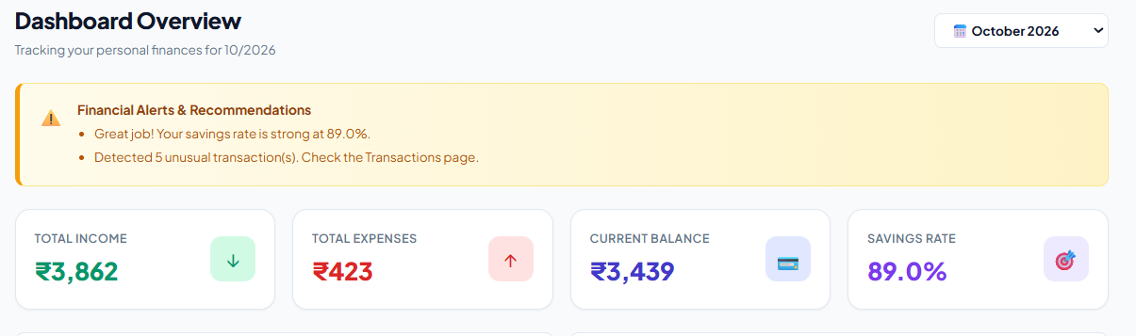
Fig 3.1: Interactive Dashboard Overview displaying Income, Expenses, Balance, and Savings Rate Cards
Description: The primary command dashboard renders high-level KPI tiles including Total Monthly Income (green card), Total Monthly Expenses (red card), Net Cash Balance (blue card), and Savings Rate percentage (purple card). It features dynamic advisory alerts indicating safe daily targets and budget health status.
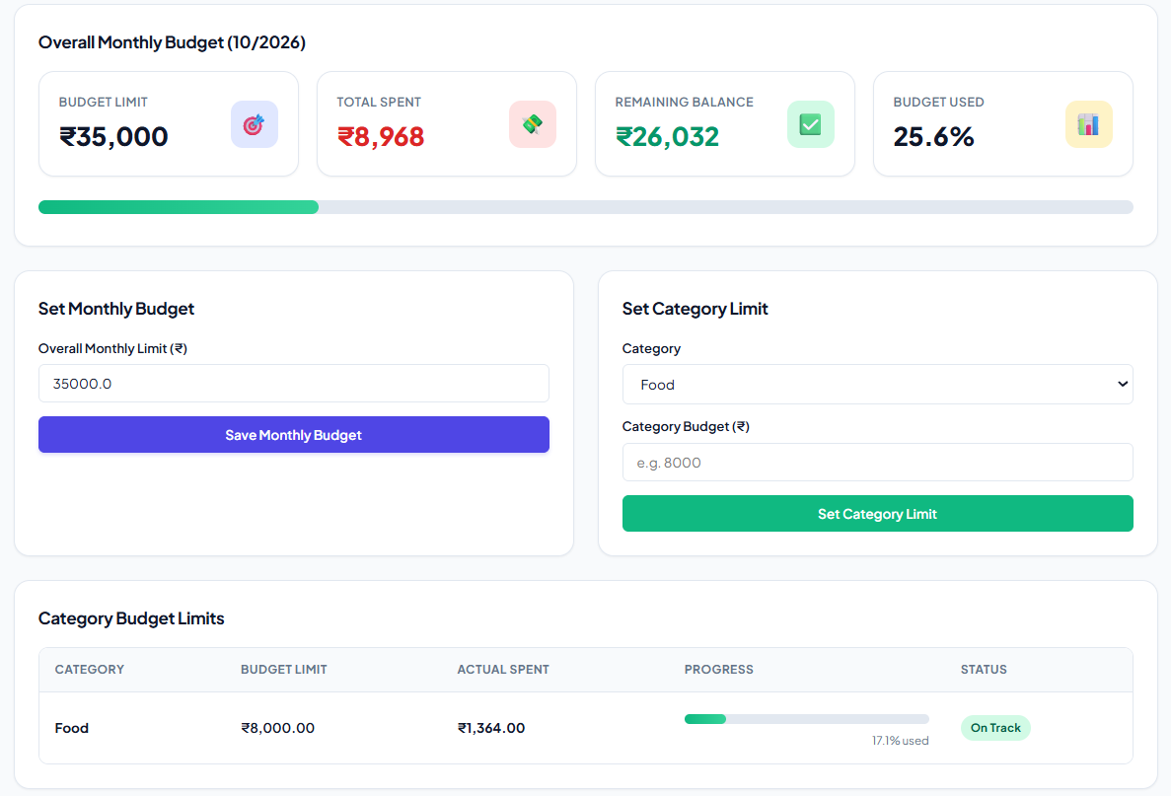
Fig 3.2: Budget Management Interface showing Overall Monthly Budget and Category-wise Spending Limits
Description: The budget configuration interface allows users to define overall monthly limits alongside granular category-specific caps (Food, Transport, Bills). Progress bars dynamically update from green (healthy) to amber (warning) and red (breached), alerting users to imminent overspending.
18
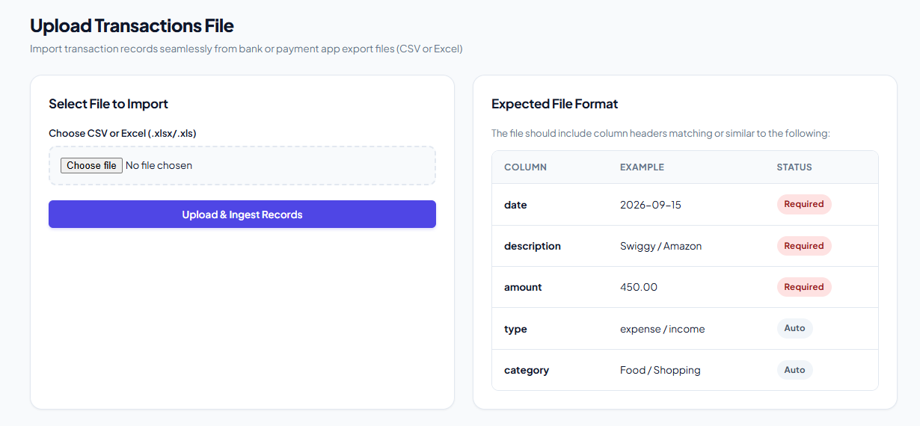
Fig 3.3: Multi-Source Statement Upload Portal supporting PhonePe, Paytm, and Bank Statement Ingestion
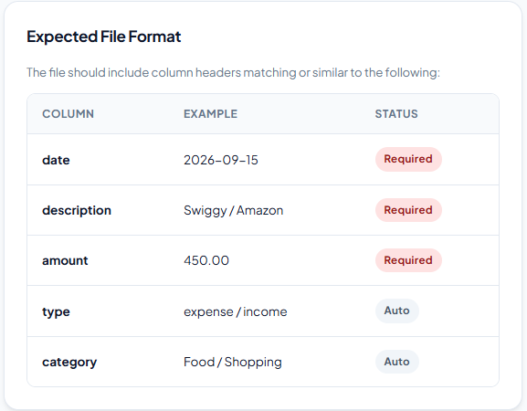
Description: The file upload gateway facilitates drag-and-drop ingestion of commercial CSV and Excel statement exports. Users select their export file, and the ingestion engine automatically identifies statement origins and triggers header scanning routines.
Fig 3.4: Expected File Format and Column Specification Guide on Upload Interface
Description: The upload module displays a structured schema guideline indicating mandatory fields (date, description, amount) and auto-populated attributes (type, category). This assists users in aligning custom banking or digital payment statements with the system's ingestion engine to prevent parsing and schema mismatch errors
19
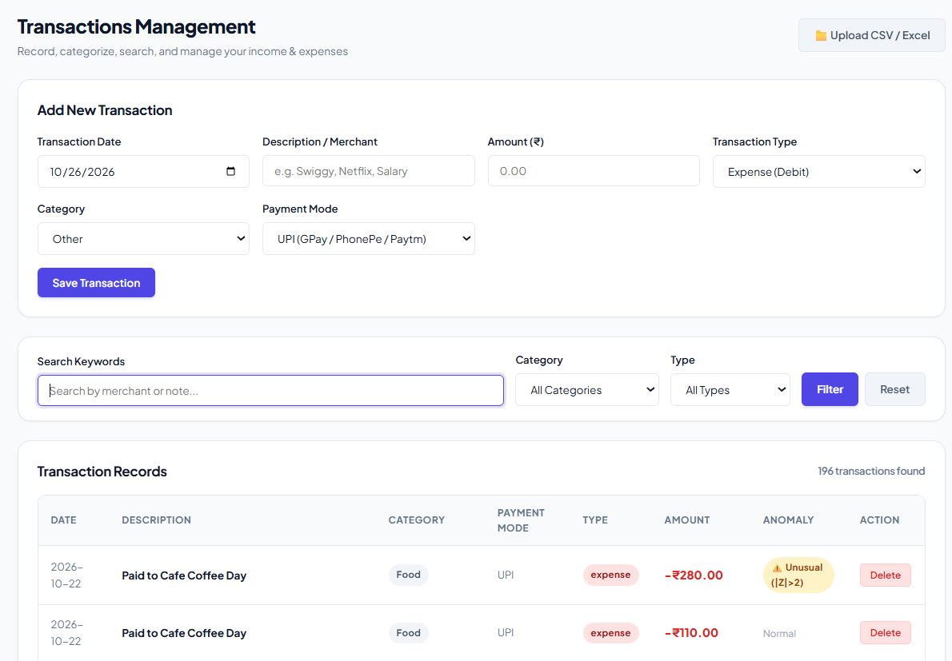
Fig 3.5: Master Transaction Inspection Table with Domain Categories and Spending Nature Tags
Description: A comprehensive data table presenting all recorded transactions with real-time category labels and behavioral nature classifications (Fixed, Recurring-Variable, Discretionary Variable). Users can filter transactions by category, payment instrument, or date ranges.
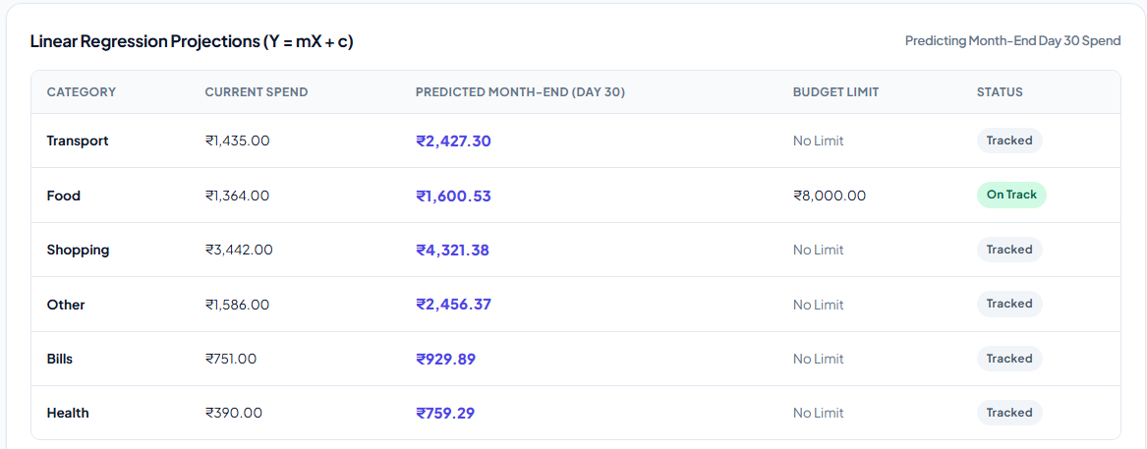
Fig 3.6: Category-Wise Month-End Spend Projections using Linear Regression
Description: Tabular view of the linear regression forecasting model (Y=mX+c) projecting final Day-30 category expenditures. It compares current actual disbursements with projected month-end totals and user-defined budget thresholds, flagging categories on track versus those requiring spending discipline before month-end.
20
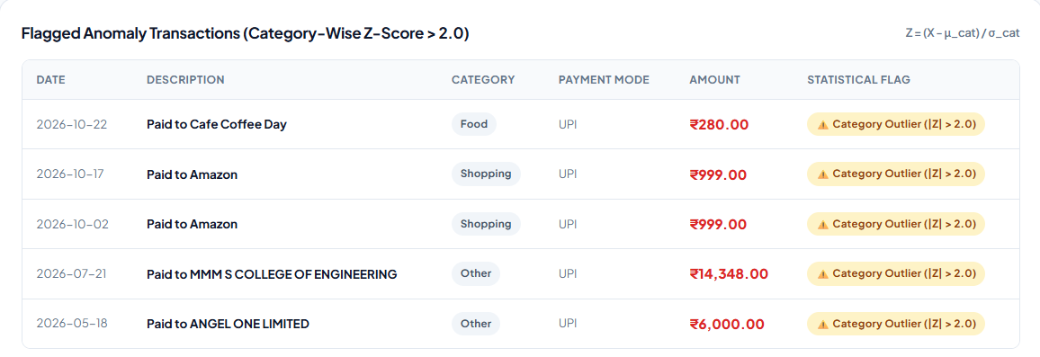
Fig 3.7: Statistical Outlier and Anomaly Transaction Detection Ledger
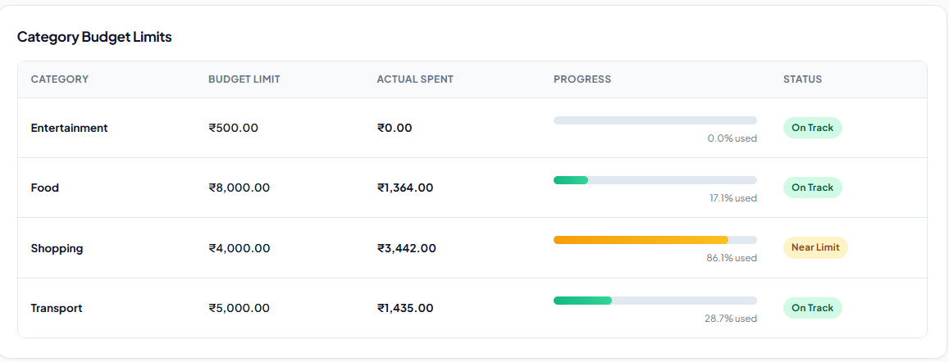
Description: Tabular inspection view of anomalous transactions flagged by the statistical Z-score engine (Z>2.0). The interface highlights high-ticket deviations across individual categories (e.g., college fees, major e-commerce outlays) with amber warning tags, allowing users to quickly verify unusual or uncharacteristic debit transactions.

Fig 3.8: Category-wise Budget vs Actual Expenditure Comparative Progress Bar Chart
Description: A horizontal comparative bar visualization contrasting current expenditures against allocated budget limits across all active spending categories, enabling instant visual discovery of categories approaching or exceeding their financial caps.
21
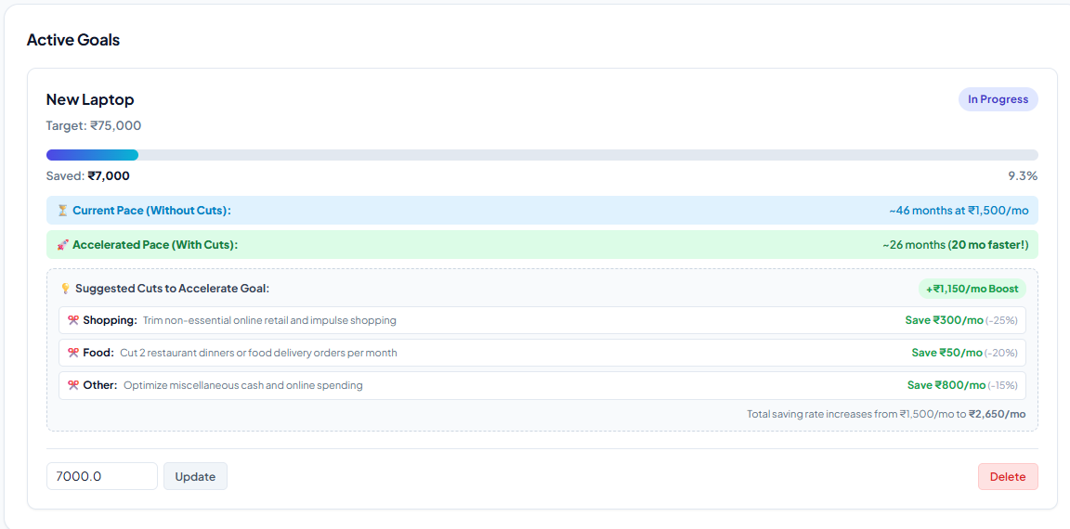
Fig 3.9: Financial Goal Tracking View showing Milestone Target Dates and Monthly Allocation Status
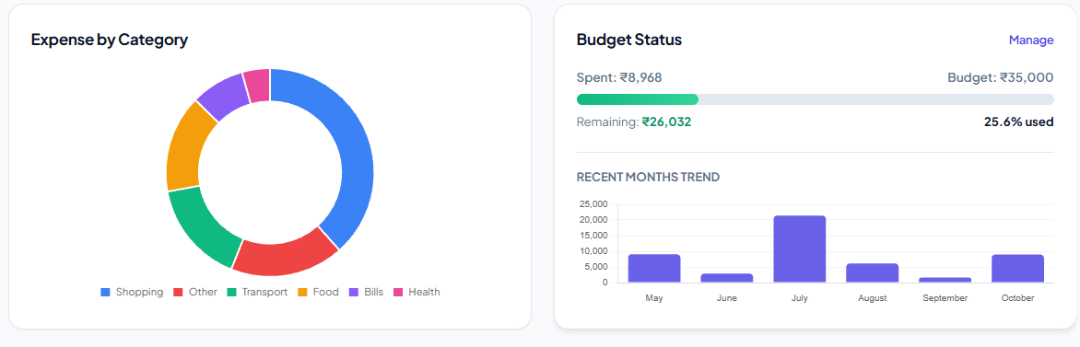
Description: Goal monitoring interface enabling users to configure multi-month savings objectives with visual progress meters, current accumulated capital, target completion dates, and monthly contribution pacing.

Fig 3.10: Category-wise Monthly Spending Breakdown Doughnut Chart with Interactive Legend
Description: Responsive Chart.js doughnut chart rendering the proportional breakdown of monthly expenditures across Food, Transport, Bills, Shopping, and Entertainment, featuring hover tooltips with exact rupee sums.
22
CHAPTER 4
CONCLUSION
The Personal Finance & Expense Analyzer successfully bridges the gap between passive financial recording and proactive savings protection by transforming raw financial transactions into actionable insights. Unlike conventional commercial applications that primarily notify users after budgets have been breached, the proposed system implements an end-to-end six-stage predictive pipeline that enables users to monitor spending patterns, anticipate potential financial risks, and make informed decisions before the end of the month. By integrating automated statement preprocessing, transaction categorization, Ordinary Least Squares (OLS) Linear Regression forecasting, and Isolation Forest-based anomaly detection, the application identifies deviations in spending trajectories and highlights potential budget overruns even halfway through the month.
The core innovation lies in translating abstract category-wise budget overruns into tangible estimates of potential savings loss while dynamically recalculating safe daily spending targets based on the user's remaining budget and the number of days left in the month. This approach helps users understand not only where their money is being spent but also how their current spending habits may affect their financial goals. Additionally, the system provides category-specific insights and recommendations, enabling users to identify unusual expenses, control discretionary spending, and maintain better financial discipline. Its structured database and interactive dashboard further support efficient transaction management, financial visualization, and the tracking of budgets and savings objectives.
Rigorous testing using authentic, multi-month PhonePe statement exports demonstrated zero tokenization errors, accurate transaction classification across eight functional spending domains, and sub-second execution speeds under the tested conditions. These results indicate that the system can process real-world financial data efficiently while maintaining consistency in transaction handling and analytical outputs. By combining predictive analytics, anomaly detection, and personalized spending guidance within a single application, the Personal Finance & Expense Analyzer offers a practical, low-cost, and privacy-focused approach to personal financial management. Overall, the proposed system moves beyond conventional expense tracking toward a proactive financial assistance framework that encourages responsible spending, early risk identification, improved budget adherence, and sustainable long-term savings habits.

23
4.1 FUTURE SCOPE
The modular architecture of the system allows several promising avenues for future research and technical enhancement:
- 1. Direct Account Aggregator (AA) Integration: Integrating with the Reserve Bank of India's Account Aggregator framework will allow real-time automated streaming of transaction records via encrypted APIs, eliminating manual statement uploads while maintaining privacy.
- 2. Deep Learning Sequence Forecasting: Incorporating Long Short-Term Memory (LSTM) recurrent neural networks or Temporal Fusion Transformers (TFT) will capture complex seasonal expenditure cycles, such as annual festival shopping or quarterly tuition fees.
- 3. Optical Character Recognition (OCR) for Cash Receipts: Embedding a mobile-accessible receipt scanner powered by lightweight computer vision will enable automatic parsing of physical paper bills, bridging the gap between cash and digital transactions.
- 4. Multi-Currency & Cross-Platform Mobile PWA: Expanding the backend to handle multi-currency conversions and wrapping the frontend into a Progressive Web Application (PWA) will provide offline mobile support across Android and iOS devices.
24
REFERENCES
- IEEE Paper: “SmartSpend: A Unified Artificial Intelligence Powered Personal Finance Dashboard Integrating Fraud Detection, Spending Forecasting and Budget Recommendation”– https://ieeexplore.ieee.org/document/11569599
- IEEE Paper: “SpendCheck: An LLM-Based Mobile Personal Finance Tracker with Automated Categorization and Smart Budgeting,” IEEE Global Symposium on Emerging and Communication Technologies – https://ieeexplore.ieee.org/document/11620428
- IEEE Paper: “SmartSpend: A Hybrid Framework for Automated Expense Analysis and Semantic Categorization,” IEEE International Conference on NextGen Data Science and Analytics – https://ieeexplore.ieee.org/document/11652222
- IEEE Paper: “Isolation Forest: Unsupervised Anomaly and Outlier Detection in Transaction Data,” Eighth IEEE International Conference on Data Mining (ICDM) – https://ieeexplore.ieee.org/document/4781136
- Research Paper: “Smart Expense Tracker with Spending Pattern Prediction Using Machine Learning,” International Journal of Research Publication and Reviews – https://ijrpr.com/uploads/V7ISSUE2/IJRPR59862.pdf
- IEEE Paper: “Automatic User Categorization and Spending Behavior Profiling Through Large Transaction Data,” IEEE International Conference on Multimedia and Expo (ICME) – https://ieeexplore.ieee.org/document/8784878
- IEEE Paper: “Credit Card Fraud and Financial Transaction Anomaly Detection Using Isolation Forest Algorithm,” IEEE International Conference on Computing, Communication and Networking – https://ieeexplore.ieee.org/document/9243452
- Research Paper: “Smart Expense and Goal Tracker Using Machine Learning and Regression Analysis” –https://ijrpr.com/uploads/V6ISSUE8/IJRPR52213.pdf
- Research Paper: “FinSmart: An Intelligent Personal Finance & Budget Tracker Application,” IRJMETS https://www.irjmets.com/upload_newfiles/irjmets71100072326/paper_file/irjmets71100072326.pdf
- National Payments Corporation of India (NPCI) – UPI Transaction Specifications & Digital Payment Ecosystem – https://www.npci.org.in/what-we-do/upi/product-overview
- Reserve Bank of India (RBI) – Master Directions for Non-Banking Financial Company - Account Aggregator (NBFC-AA) Directions https://www.rbi.org.in/Scripts/BS_ViewMasDirections.aspx?id=10598
- Ministry of Law and Justice, Government of India – The Digital Personal Data Protection Act, 2023 (Act No. 22 of 2023).
- R. H. Thaler, “Mental Accounting Matters,” Journal of Behavioral Decision Making, vol. 12, no. 3, pp. 183–206, 1999.
- F. Pedregosa et al., “Scikit-learn: Machine Learning in Python,” Journal of Machine Learning Research (JMLR), vol. 12, pp. 2825–2830, 2011.
25

